**VISVESVARAYA Technological University**

**JNANA SANGAMA, BelAgaVI**

**An Internship Report**

***On***

“**Anti-Poaching Alarm System for Tree**”

***Submitted as part of curriculum 2021 scheme with course code 21INT49***

**BACHELOR OF ENGINEERING**

In

**DEPARTMENT OF COMPUTER SCIENCE AND ENGINEERING**

***Submitted By***

**RAHUL D R 4GM21CS075**

**SRUJAN K S 4GM21CS109**

**VEDANTH K N 4GM21CS118**

**YATHISH RAO M R 4GM21CS126**

***Internship Carried Out in* SIRINTEL TECHNOLOGIES**

***Davanagere***

Internal Guide

**Mr. SANDEEPA G S**

**Assistant Professor, GMIT**

External Guide/Mentor

**Mr. SHIVALI S**

**SIRINTEL TECHNOLOGIES**



**DEPARTMENT OF COMPUTER SCIENCE AND ENGINEERING**

**GM INSTITUTE OF TECHNOLOGY, DAVANGERE**

(Affiliated to VTU, Belagavi, Approved by AICTE -New Delhi & Govt. of Karnataka)

(Accredited by NBA New Delhi, Valid up to 30.06.2025)

**2022-2023**

Srishyla Educational Trust (R), Bheemasamudra

**GM INSTITUTE OF TECHNOLOGY, DAVANGERE**

(Affiliated to VTU, Belagavi, Approved by AICTE -New Delhi & Govt. of Karnataka)

**DEPARTMENT OF COMPUTER SCIENCE AND ENGINEERING**

**(Accredited by NBA New Delhi, Valid up to 30.06.2025)**



**CERTIFICATE**

Certified that the Internship titled **“ANTI-POACHING ALARM SYSTEM FOR TREE”** is a bona fide work carried out by **RAHUL D R (4GM21CS075), SRUJAN K S (4GM21CS109), VEDANTH K N (4GM21CS118), YATHISH RAO M R (4GM21CS126)** as per curriculum scheme 2021 with course code 21INT49 of Bachelor of Engineering in the Department of Computer Science and Engineeringof the Visvesvaraya Technological University, Belagavi, during the year 2022-23. The internship report has been approved as it satisfies the academic requirements with respect to the Internship work prescribed for Bachelor of Engineering Degree.

**Guide**

**Mr. Sandeepa G S**

**Internship Coordinator**

**Mr. Kotreshi S N**

**Head of the Department**

|  |
| --- |
| **Mr. Santosh Kumar M** |

**External Viva**

**Name of the Examiners Signature with Date**

1.

2

**ACKNOWLEDGEMENT**

The joy and satisfaction that accompany the successful completion of any task would be incomplete without the mention of the people who made it possible.

Wewould like to express our gratitude to our **Principal, Dr. Sanjay Pande M B** for providing us a congenial environment for engineering studies and also for having showed us the way to carry out the Internship work.

We consider it a privilege and honour to express our sincere thanks to **Mr. Santoshkumar M** Assistant Professor and Head, Department of Computer Science and Engineering for his support and invaluable guidance throughout the tenure of this Internship work.

We would like to thank our Internship Co-Ordinator **Mr. Kotreshi S N**, Assistant Professor, Department of Computer Science and Engineering for support and encouragement for this Internship work.

We would like to thank our Guide **Mr. Sandeepa G S,** Assistant Professor, Department of Computer Science and Engineering for support, guidance, motivation, encouragement for the successful completion of this Internship work.

We would like to thank our mentor **Mr. Shivali S, Sirintel technologies,** for providing resources, sharing knowledge and providing industry working environment.

We intend to thank all the teaching and non-teaching staffs of our Department of Computer Science and Engineering for their immense help and co-operation.

Finally, we would like to express our gratitude to our parents and friends who always stood by us.

**Student Name**

**RAHUL D R4GM21CS075**

**SRUJAN K S 4GM21CS109**

**VEDANTH K N 4GM21CS118**

**YATHISH RAO M R 4GM21CS126**

**CONTENTS Page No.**

**Chapter 1: Company Profile 02 - 05**

* 1. History
  2. Vision And Mission
  3. Company Values
  4. Strategy
  5. Commitment Policy
  6. Quality Policy
  7. Future Plans of Company

**Chapter 2: Introduction 06 - 08**

* 1. Problem Statement
  2. Objectives
  3. Proposed Solution

**Chapter 3: Methodology 09 - 13**

* 1. Block Diagram
  2. ESP8266 Node MCU
  3. Accelrometer
  4. Buzzer

**Chapter 4: Task Performed 14 - 24**

* 1. Tinkercad
  2. Arduino IDE
  3. Hardware Components
  4. Blynk Software
  5. Code

**Chapter 5: Learning Outcomes 25 -26**

* 1. Technical outcomes
  2. Personality development
  3. Time management
  4. Skills

**Chapter 6: Result and Conclusions 27-28**

**Reference 29**

**LIST OF FIGURES**

FIGURE NO. FIGURE NAME PAGE NO

3.1 Proposed System **10**

3.2 Block Diagram of Anti-Poaching Alarm System **11**

**CHAPTER 1**

**ABOUT THE COMPANY**

About the company SIRINTEL TECHNOLOGIES: Sirintel is a leading upcoming Information Technology (IT) Service provider who delivers the complete solution for the entire software necessities with the assured quality. We proved our competence in IT consulting, Technology services, R&D and Technology service, IEEE project development, corporate training, Academic Project enhancement, Business Process Outsourcing, Web Designing, Content writing, Research Article submission, Blog posting, Blogger services, IT hardware, System compiling, Telecom products and services, Management solution and many more. We bestowed the above services not for the client’s satisfaction but delight them. We gained the local, national and international clients due to the dedicate services since 2015.

**1.1 HISTORY**

* **HR DIRECTOR: MAMATA T**
* **TECHNICAL HEAD: SHIVALI S**
* **COMPANY PH: +91-89712791247**
* **EMAIL ID: sirintel.tec@gmail.com**

One good idea can rule the world. The idea of company was started with the expectation of meeting requirements of real time projects. Sirintel Technologies is a leading firm providing technological solutions to various students across the State of Karnataka to enrich their knowledge with Practical experience and live training through various projects. Being situated in the City of Davangere, the center place of Karnataka, Sirintel Technologies is accessible to all the students throughout Karnataka. It is having a geographical advantage being in the center city of Karnataka.

**1.2 VISION**

The Main vision of Sirintel Technologies is “To be a key player in deployment of Knowledge Technology, By Producing and Providing Versatile and Resourceful Professionals to the growing Industries. The vision of Sirintel Technologies is to involve its students in never-ending Engineering Research and make them excel in Quality Education. In the years to come its vision is to keep its students in the forefront in Engineering and Technological Education. Moreover, it should remain forever a world class institution for technological education and scientific research for public good.”

**1.2 MISSION**

To create and sustain a community of learning in which students acquire knowledge and learn to apply it professionally with due consideration for ethical, ecological and economic issues

* To pursue research and disseminate research findings
* To provide knowledge-based technological services to satisfy the needs of society and the industry
* To help in building national capabilities in science, technology, humanities, management, education and research

**1.3 COMPANY VALUES**

* Diversity: Considerable diversity in the project design and acceptance. Application of diversified tools and technologies.
* Team work: Teamwork of experts make it more worth it. Engagement of various maestro on the subject make is more disciplined
* Knowledge Sharing and enhancement: Knowledge is available in plenty. This knowledge is to reach students in simple and understandable way with the help of experts.
* Transparency: Transparency in all the work, training, projects, simulation projects and live projects is maintained so give a better insight to the students
* Commitment: Commitment of spreading and enhancing knowledge and presenting better people with high skills to the organizations and to create Job Opportunities
* Continuous improvement: Continuous improvement through upgradation of Technology, tools, designs, knowledge, expertise and experiments.

**1.4 STRATEGY**

Our strategy is built on the strong foundation of corporate values. To drive the focus of entire organization and to ensure successful implementation we have designed strategies such as

* Use advanced tools and technologies
* Continuous improvement and upgradation
* Inspire students
* Share Expertise knowledge

**1.5 COMMITMENT POLICY**

We will achieve positive change across the globe through:

* Inspiring Students
* Establishing ultimate Expert Service Arena
* Knowledge Sharing and enhancement
* Embracing Sirintel Technologies to be the global performer
* Produce Pristine results and project solutions

Sirintel Technologies conduct a continuous set of workshops, Internship and Training Programs to help students be ready for the pragmatic and realistic practices for actual job on the site. Students are seasoned to be skilled in an area of expertise to be pristine and successful. Sirintel Technologies is also conducting live projects to give practical approach and understanding to students so that the subject knowledge is acquired with mastery over it with the help of various experts across the globe.

**1.6 QUALITY POLICY**

* Sirintel Technologies commitment to quality extends to every aspect of business and technology. The overarching goal is to fine tune and output the best in the student with the practical and theoretical mastery over the area of expertise. In order to ensure robust and impeccable solution, Sirintel Technologies follows the following major principles:
* Use advanced software’s
* Use advanced and proven technologies
* Design tailor made solutions and projects
* The best fine tune process of training and knowledge impartation
* Work with experts, specialists and maestro in each discipline
* Provide close student and project monitoring
* Round the clock accessibility to the students with the experts
* Online support in special cases
* Maintain a quality of culture
* Strive on continuous improvement and upgradation
* Ensure high quality results

**1.7 FUTURE PLANS OF COMPANY:**

The company is new and is having big plans to hit the big success in future. To ensure that the Sirintel Technologies achieves its goals in the long run, we are carrying on the following activities:

* We are approaching the Government with new projects in various fields such as transportation, maintenance of records, Rural data etc.
* We are also planning to design various medical electronic devices at the lower cost.
* Planning to be broad-based all-over India and to enter the global markets in future.

**CHAPTER 2**

**INTRODUCTION**

“IoT Early Flood Detection & Avoidance System” is an intelligent system which keeps close watch over

various natural factors to predict a flood, so we can embrace ourselves for caution, to minimize the damage

caused by the flood. Natural disasters like a flood can be devastating leading to property damage and loss of

lives. To eliminate or lessen the impacts of the flood, the system uses various natural factors to detect flood. The

system has a Wi-Fi connectivity; thus, it is collected data can be accessed from anywhere quite easily using IoT.

To detect a flood the system observes various natural factors, which includes humidity, temperature, water level

and flow level. To collect data of mentioned natural factors the system consists of different sensors which

collects data for individual parameters. For detecting changes in humidity and temperature the system has a

DHT11 Digital Temperature Humidity Sensor. It is an advanced sensor module with consists of resistive

humidity and temperature detection components. The water level is always under observation by a float sensor,

which work by opening and closing circuits (dry contacts) as water levels rise and fall. It normally rests in the

closed position, meaning the circuit is incomplete and no electricity is passing through the wires yet. Once the

water level drops below a predetermined point, the circuit completes itself and sends electricity through the

completed circuit to trigger an alarm. The flow sensor on the system keeps eye on the flow of water. The water

flow sensor consists of a plastic valve body, a water rotor, and a hall-effect sensor. When water flows through

the rotor, rotor rolls. Its speed changes with different rate of flow.

The system also consists of a HC-SR04 Ultrasonic Range Finder Distance Sensor. The Ultrasonic sensor works

on the principle of SONAR and is designed to measure the distance using ultrasonic wave to determine the

distance of an object from the sensor. All the sensors are connected to Arduino UNO, which processes and saves

data. The system has Wi-Fi feature, which is useful to access the system and its data over IoT

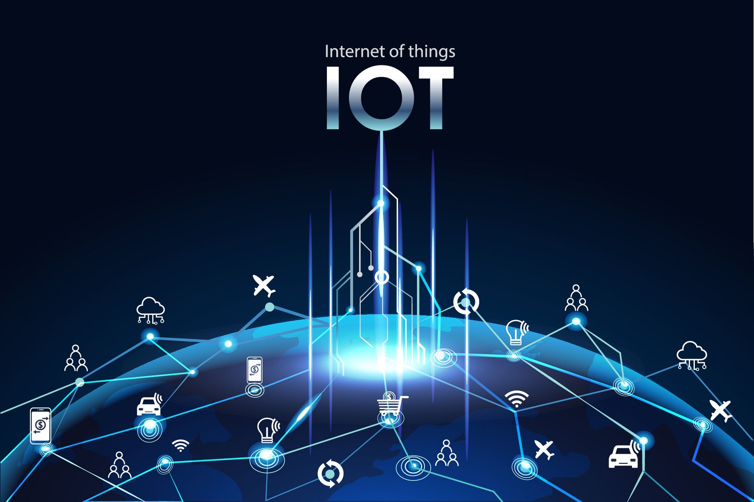

IoT, which stands for Internet of Things, refers to the network of physical devices embedded with sensors, software, and connectivity capabilities that enable them to collect and exchange data over the internet. These devices can be anything from everyday objects like household appliances, vehicles, and wearable devices to industrial machinery, medical equipment, and infrastructure systems.

The concept behind IoT is to connect these devices to the internet and allow them to communicate with each other, as well as with humans, to perform various tasks, automate processes, and enhance efficiency and convenience in different domains. The interconnectedness and data exchange among IoT devices enable real-time monitoring, analysis, and control of physical systems, leading to improved decision-making, cost savings, and new opportunities for innovation.

**Anti-Poaching Alarm System for Tree**

* Poaching is not limited to India alone. Countries like China, Australia, and various African nations are also grappling with the issue of poaching.
* Indian sandalwood is highly valued, costing around 12,000 to 13,000 INR per kilogram. In contrast, in the global market, Red Sanders, another type of sandalwood, costs only 10 cents per ton.
* The Indian sandalwood tree has become rare, prompting the Indian government to restrict its exportation in order to control potential loss.
* The government has imposed a maximum purchase limit of 3.8 kilograms on individuals to prevent excessive buying.
* If a sandalwood tree is under government control, its removal is prohibited, whether it is on private property or within a sanctuary, until the tree reaches the age of thirty.
* The smuggling of sandalwood has resulted in economic and social issues in bordering areas of India.
* The primary objective of the project is to develop a system that can be utilized to restrict the poaching of sandalwood trees.

**2.1 PROBLEM STATEMENT:**

* **Illegal Logging and Poaching**: The project aims to address the issue of illegal logging and poaching, which is not only prevalent in India but also in countries like China, Australia, and African nations. The high demand for Indian sandalwood has led to its scarcity, prompting the Indian government to restrict its exportation. However, smuggling of sandalwood continues to pose economic and security challenges, particularly in regions bordering India.
* **Forest Fires**: The misuse of fire for converting forests into agricultural lands has resulted in frequent and devastating forest fires. These fires are often caused by human activities and pose a significant threat to the forest ecosystem, wildlife, and nearby communities. It is essential to develop a system that can help prevent forest fires and protect the forests from anthropogenic activities.
* **Need for Surveillance and Monitoring**: The existing methods of forest protection often require guards to travel throughout the forest, making it difficult to cover vast areas effectively. To address this issue, the project aims to develop a surveillance and monitoring system that can be deployed in any forest area heavily impacted by illegal logging and smuggling. The system should provide real-time visuals and accurate location data of any unauthorized activities, such as tree cutting or smuggling, to enable prompt response and action.

**2.2 OBJECTIVES:**

Our main objective is to:

* The goal of the project is to prevent poaching, illegal logging, and other human-induced activities in the forest.
* The proposed system can be implemented in any forest area that is highly affected by poaching and illegal cutting.
* The system eliminates the need for guards to physically patrol the entire forest. Instead, the base station can receive visuals of all the activities happening in the forest.

**2. 4 PROPOSED SOLUTIONS:**

* **Implementation of a Sensor Network**: Deploy a network of sensors, including motion sensors, infrared cameras, and sound sensors, in the forested areas to monitor and detect any unauthorized activities such as poaching and illegal logging.
* **Integration with Microcontroller**: Use a microcontroller unit as the central processing unit to receive and process data from the sensor network. The microcontroller will analyze the sensor data to identify any suspicious activities and categorize them as potential instances of poaching, illegal logging, or other anthropogenic activities.
* **Data Transmission and Visualization**: Establish a data transmission system, such as wireless communication or IoT, to transmit the processed data from the microcontroller to a central collector unit or base station. At the base station, the collected data will be visualized on a monitoring system, providing real-time visuals of the forest activities to the authorities.
* **Environmental Conditions Monitoring**: Equip the system with additional sensors to monitor environmental conditions in the forest, such as temperature, humidity, and air quality. This data will be processed by the microcontroller and used to detect potential forest fire risks. If dangerous conditions are detected, immediate alerts will be sent to prevent forest fires.
* **Centralized Monitoring and Control**: Establish a centralized control center where authorities can monitor the forest activities, receive alerts, and take necessary actions. The system will eliminate the need for physical patrols, as the visuals and data collected by the sensors will provide comprehensive coverage of the forested areas.
* **Data Analysis and Insights**: Collect and analyze the data over time to identify patterns, hotspots, and trends related to poaching, illegal logging, and forest fire risks. These insights will help authorities develop targeted strategies for conservation, prevention, and enforcement.

**CHAPTER 3**

**METHODOLOGY**

* **Sensor Network**: A network of sensors will be deployed in the forest area to monitor and detect any unauthorized activities. These sensors can include motion sensors, infrared cameras, and sound sensors. They will continuously monitor the forest for any suspicious movements or sounds.
* **Microcontroller Unit**: A central microcontroller unit will be responsible for processing the data received from the sensor network. It will analyze the sensor data to identify any illegal activities, such as tree cutting or unauthorized entry into the protected areas.
* **Data Transmission**: The microcontroller unit will transmit the processed data to a central receiver unit. This can be done using wireless communication technologies such as Wi-Fi or radio frequency. The receiver unit will be located at a control center or a base station.
* **Data Analysis and Alert System**: The receiver unit will analyze the received data and determine if there is any indication of forest fire or illegal activities. If a threat is detected, an alert system will be triggered to notify the authorities or forest management personnel.
* **Remote Monitoring**: The base station or control center will have a display system to visualize the sensor data and monitor the forest in real-time. This will allow the authorities to have a comprehensive view of the forest and respond quickly to any threats or illegal activities.

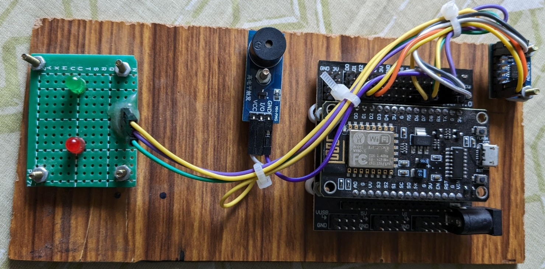

**Fig 3.1 Proposed System**

**3.1 BLOCK DIAGRAM:**

POWER

BUZZER

Accelerometer

Sensor

ESP8266

NodeMCU

LED

ANDROID APP

**Fig 3.2 Block Diagram of Anti-Poaching Alarm System for Tree**

**3.2 ESP8266 Node MCU:**

* 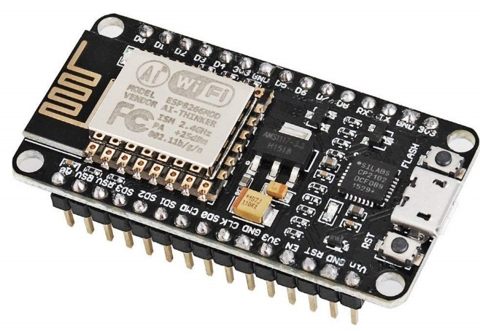ESP8266 Overview: The ESP8266 is a low-cost Wi-Fi microchip module that enables Internet of Things (IoT) applications. It integrates a microcontroller and Wi-Fi capabilities, allowing for wireless communication and connectivity.
* **Microcontroller and Processing Power:** The ESP8266 module contains a 32-bit Ten silica microcontroller, which provides sufficient processing power for running applications and handling Wi-Fi communication.
* **Wi-Fi Connectivity:** The module supports 802.11 b/g/n Wi-Fi standards, allowing it to connect to Wi-Fi networks and communicate with other devices and services over the internet.
* **GPIO Pins:** The ESP8266 module comes with GPIO (General Purpose Input/Output) pins that can be used for digital input and output operations. These pins enable the connection of various sensors, actuators, and external devices.
* **Programming Capabilities:** The ESP8266 module can be programmed using the Arduino IDE or other compatible programming environments. This makes it easy for developers to write and upload firmware to the module.
* **Firmware Options:** The ESP8266 module can be programmed with different firmware options, such as the NodeMCU firmware or the Arduino core for ESP8266. These firmware options provide libraries and APIs for simplifying Wi-Fi communication and other IoT-related tasks.
* **Development Boards:** Various development boards are available that feature the ESP8266 module, such as the NodeMCU and WeMo’s D1 Mini. These boards provide additional features like USB connectivity, voltage regulation, and additional GPIO pins, making it easier to prototype and develop IoT projects.
* **Low Power Consumption:** The ESP8266 module is designed to operate efficiently with low power consumption. This feature is particularly useful for battery-powered or energy-conscious applications.
* **Wide Range of Applications:** The ESP8266 module is widely used in IoT applications, including home automation, sensor networks, wireless sensor monitoring, smart agriculture, and industrial automation. Its low cost, Wi-Fi connectivity, and ease of programming make it a popular choice for IoT projects.

**3.3 ACCELEROMETER:**

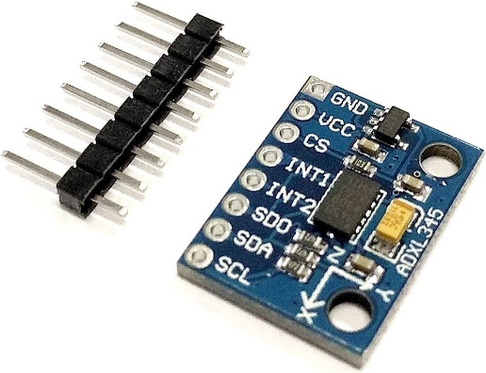An accelerometer is an electromechanical device which is used to measure acceleration forces and proper acceleration. Such forces could be static. Acceleration gives measurement of the change in velocity. sensor’s output signal specifications supported the level of acceleration and Which is typically specified in ±g. This is the greatest amount of acceleration; the part of acceleration can measure and accurately represent as an output. For example, the output of a ±3g. Most of the cases, accelerometer is linear with acceleration up to ±3g. If it is accelerated at 4g, then the output may rail

**Features**

It has completed 3-axis sensing It can measure the static acceleration of gravity in tilt sensing applications, as well as dynamic acceleration and we get result from motion, shock, or vibration. It is Small and thin in size. And it has low-profile package. It is Low power - 350 μA (typical) it provides Single-supply operation up to 1.8 V to 3.6 V. it has Excellent temperature stability and BW adjustment with a single capacitor per axis.

**Output Data Rate**

In digital-output accelerometers, it defines the rate at which data is sampled. the highest frequency signal is Bandwidth and that can be sampled without aliasing by the specified Output Data Rate. In analog-output accelerometers, bandwidth is defined as the signal frequency at which the response falls to -3dB of the response to DC acceleration.

**Total Noise**

The random deviation from the ideal output and it is equal to the multiplied product of the Noise Density and the also it is square root of the Noise Bandwidth. The units for this parameter are typically mg-RMS

**3.4 BUZZER:**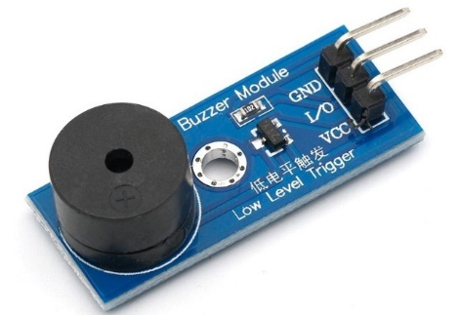

A buzzer is an electronic audio signaling device commonly used for generating sound alerts, notifications, or alarms in various electronic systems and applications. It produces a distinctive buzzing or beeping sound when activated.

**Features:**

* Audible Alert: The main feature of a buzzer is its ability to produce a loud and clear sound, making it suitable for applications that require an audible alert or notification.
* Simple Design: Buzzer circuits are relatively simple, typically consisting of a coil or piezoelectric element, a diaphragm, and a driver circuit. This simplicity makes them easy to integrate into different electronic projects.
* Wide Voltage Range: Buzzer modules are available in various voltage ranges, allowing compatibility with different power supply requirements.
* Compact Size: Buzzer components are generally compact and lightweight, making them suitable for space-constrained applications.
* Versatile Applications: Buzzers find applications in a wide range of fields, including security systems, electronic games, appliances, automotive systems, medical devices, and industrial equipment.

**Specifications:**

* Operating Voltage: Typically, buzzers operate within a voltage range of 3V to 12V, although there are variations available for higher voltages.
* Sound Output: The sound output of a buzzer is measured in decibels (dB) and can range from around 80dB to 120dB, depending on the specific model and type.
* Frequency Range: Buzzer modules produce sound at a specific frequency range, usually between 2kHz to 4kHz, but this can vary based on the design and intended application.

**Chapter 4:**

**TASK PERFORMED**

**4.1 Tinkercad:**

Tinkercad is an online platform that provides a virtual environment for simulating Arduino projects. It allows to design and test circuits using a variety of electronic components and Arduino boards. We simulate the behavior of our Arduino code and interact with virtual components without the need for physical hardware. Tinkercad also provides a code editor where we write and upload Arduino sketches to the virtual Arduino board. It's a convenient tool for beginners to learn and experiment with Arduino programming and circuit design before moving on to physical implementations.

**4.2 Arduino IDE**:

The Arduino IDE (Integrated Development Environment) is a software application that is used to write, compile, and upload code to Arduino microcontrollers. It provides a user-friendly interface for programming Arduino boards and simplifies the development of Arduino projects. We use some key features and functionalities of the Arduino IDE, they are:

* **Code Editor**: The Arduino IDE includes a code editor where we write and edit our Arduino sketches (programs). It supports basic code editing features like syntax highlighting, auto-indentation, and code completion.
* **Library Manager**: The IDE provides a library manager that allows to easily browse, install, and manage Arduino libraries. Libraries are pre-written code that provide additional functionalities and features to our Arduino projects.
* **Board Manager**: The Arduino IDE includes a board manager in that we select and install the appropriate board support package for our specific Arduino board. This enables we to compile and upload code to the correct board.
* **Serial Monitor**: The IDE has a built-in serial monitor that allows we to communicate with our Arduino board and view the data being sent or received over the serial port. It is useful for debugging and testing for Arduino projects.

**4.3 Hardware components:**

* **Arduino Uno**: Arduino Uno is a popular microcontroller board based on the ATmega328P microcontroller. It provides a simple and affordable platform for prototyping and creating interactive electronic projects.
* **ESP8266**: The ESP8266 is a low-cost Wi-Fi module that enables Internet connectivity and wireless communication for microcontroller-based projects. It can be programmed using the Arduino IDE and is widely used for IoT applications.
* **Ultrasonic Sensor**: An ultrasonic sensor emits high-frequency sound waves and measures the time it takes for the waves to bounce back after hitting an object. It is commonly used for proximity sensing and distance measurement in various applications.
* **Buzzer**: A buzzer is an electronic audio signaling device that produces sound when activated. It is often used for generating alarms, notifications, or audible alerts in electronic systems.
* **Motor**: A motor is an electromechanical device that converts electrical energy into mechanical motion. It is used to create movement in various systems, such as robotics, automation, and electric vehicles.
* **Relay**: A relay is an electrically operated switch that controls the flow of current in an electrical circuit. It allows low-power signals from a microcontroller to control high-power devices, such as motors, lights, or appliances.
* **Gas Sensor**: Gas sensors are electronic devices used to detect and measure the presence and concentration of various gases in the environment. They are commonly used in applications such as air quality monitoring, gas leak detection, and industrial safety systems.
* **Temperature Sensor**: Temperature sensors are devices that measure the ambient temperature of the surrounding environment. They can provide accurate temperature readings for monitoring and controlling purposes in various applications, including weather stations, HVAC systems, and temperature-controlled environments.
* **LED (Light-Emitting Diode)**: LEDs are semiconductor devices that emit light when an electric current passes through them. They are used for illumination, visual indicators, and display purposes in a wide range of electronic devices and lighting systems due to their energy efficiency, long lifespan, and compact size.
* **LCD Display (Liquid Crystal Display)**: LCD displays are flat panel displays that use liquid crystal technology to display information in text, numbers, or graphics format. They are commonly used in electronic devices and appliances to provide visual output and user interfaces, offering low power consumption and clear visibility.
* **Humidity Sensor**: Humidity sensors, also known as hygrometers, measure and monitor the relative humidity levels in the air. They are used in various applications such as weather monitoring, HVAC systems, indoor comfort control, and agricultural and industrial processes that require precise humidity control.
* **Flame Sensor**: Flame sensors are devices that detect the presence of a flame or fire by sensing its infrared radiation. They are commonly used in fire alarm systems, gas appliances, and industrial safety systems to provide early warning and trigger appropriate actions in case of a fire or flame occurrence.

**4.4 Blynk Software:**

* Blynk is an IoT platform that allows to build custom mobile apps to control and monitor Arduino-based projects remotely.
* It provides a user-friendly mobile app available on iOS and Android that lets we design a graphical interface for our project using various widgets like buttons, sliders, and more.
* Blynk uses the Internet to establish communication between the Blynk app and our NodeMCU board.
* The communication process involves three main components: the Blynk app, Blynk Cloud (a server), and the Arduino with the Blynk library.
* To get started, we go to the Blynk software and create an account.
* After creating an account, start a new Blynk project and obtain an authentication token.
* Install the Blynk library in our Arduino IDE to connect our NodeMCU board to the Blynk cloud.
* We can choose from Blynk-supported hardware boards, that is ESP8266.
* Once our hardware is set up and connected to the Blynk cloud, we can use the Blynk app to interact with our Arduino project remotely.
* Blynk supports both digital and analog pins, allowing we to control LEDs, motors, read sensor data, and more.
* We can create custom virtual pins on the Blynk app to send and receive data between our mobile device and NodeMCU.
* Blynk also allows we to send push notifications from our NodeMCU to the Blynk app.
* Blynk also supports widgets like GPS, notifications, email, and Twitter integrations.
* While the Blynk app provides an easy-to-use interface, more complex projects might require custom coding on the Arduino side.
* Blynk is not limited to Arduino or ESP8266 and can be used with other hardware platforms like Raspberry Pi and Particle boards.

**4.5 CODE:**

#define BLYNK_TEMPLATE_ID "TMPL_pJUdY6p"

#define BLYNK_TEMPLATE_NAME "ANTI TREE INTERN"

#define BLYNK_AUTH_TOKEN "-TnukRjkhp0X4N7AlydAccPAbCQpQNPM"

#define BLYNK_PRINT Serial

#include <ESP8266WiFi.h>

#include <BlynkSimpleEsp8266.h>

#include <SoftwareSerial.h>

#include <Wire.h>

#include <Adafruit_Sensor.h>

#include <Adafruit_ADXL345_U.h>

char auth[] = "-TnukRjkhp0X4N7AlydAccPAbCQpQNPM";

char ssid[] = "PROJECT";

char pass[] = "DEMO2021";

int gled=D7;

int buz=D8;

/* Assign a unique ID to this sensor at the same time */

Adafruit_ADXL345_Unified accel = Adafruit_ADXL345_Unified(12345);

void displaySensorDetails(void)

{

Blynk.begin(auth, ssid, pass);

sensor_t sensor;

accel.getSensor(&sensor);

Serial.println("------------------------------------");

Serial.print ("Sensor: "); Serial.println(sensor.name);

Serial.print ("Driver Ver: "); Serial.println(sensor.version);

Serial.print ("Unique ID: "); Serial.println(sensor.sensor_id);

Serial.print ("Max Value: "); Serial.print(sensor.max_value); Serial.println(" m/s^2");

Serial.print ("Min Value: "); Serial.print(sensor.min_value); Serial.println(" m/s^2");

Serial.print ("Resolution: "); Serial.print(sensor.resolution); Serial.println(" m/s^2");

Serial.println("------------------------------------");

Serial.println("");

delay(500);

}

void displayDataRate(void)

{

Serial.print ("Data Rate: ");

switch(accel.getDataRate())

{

case ADXL345_DATARATE_3200_HZ:

Serial.print ("3200 ");

break;

case ADXL345_DATARATE_1600_HZ:

Serial.print ("1600 ");

break;

case ADXL345_DATARATE_800_HZ:

Serial.print ("800 ");

break;

case ADXL345_DATARATE_400_HZ:

Serial.print ("400 ");

break;

case ADXL345_DATARATE_200_HZ:

Serial.print ("200 ");

break;

case ADXL345_DATARATE_100_HZ:

Serial.print ("100 ");

break;

case ADXL345_DATARATE_50_HZ:

Serial.print ("50 ");

break;

case ADXL345_DATARATE_25_HZ:

Serial.print ("25 ");

break;

case ADXL345_DATARATE_12_5_HZ:

Serial.print ("12.5 ");

break;

case ADXL345_DATARATE_6_25HZ:

Serial.print ("6.25 ");

break;

case ADXL345_DATARATE_3_13_HZ:

Serial.print ("3.13 ");

break;

case ADXL345_DATARATE_1_56_HZ:

Serial.print ("1.56 ");

break;

case ADXL345_DATARATE_0_78_HZ:

Serial.print ("0.78 ");

break;

case ADXL345_DATARATE_0_39_HZ:

Serial.print ("0.39 ");

break;

case ADXL345_DATARATE_0_20_HZ:

Serial.print ("0.20 ");

break;

case ADXL345_DATARATE_0_10_HZ:

Serial.print ("0.10 ");

break;

default:

Serial.print ("???? ");

break;

}

Serial.println(" Hz");

}

void displayRange(void)

{

Serial.print ("Range: +/- ");

switch(accel.getRange())

{

case ADXL345_RANGE_16_G:

Serial.print ("16 ");

break;

case ADXL345_RANGE_8_G:

Serial.print ("8 ");

break;

case ADXL345_RANGE_4_G:

Serial.print ("4 ");

break;

case ADXL345_RANGE_2_G:

Serial.print ("2 ");

break;

default:

Serial.print ("?? ");

break;

}

Serial.println(" g");

}

void setup(void)

{

Serial.begin(9600);

Serial.println("Accelerometer Test"); Serial.println("");

pinMode(buz,OUTPUT);

pinMode(gled,OUTPUT);

/* Initialise the sensor */

if(!accel.begin())

{

/* There was a problem detecting the ADXL345 ... check your connections */

Serial.println("Ooops, no ADXL345 detected ... Check your wiring!");

while(1);

}

/* Set the range to whatever is appropriate for your project */

accel.setRange(ADXL345_RANGE_16_G);

/* Display some basic information on this sensor */

displaySensorDetails();

/* Display additional settings (outside the scope of sensor_t) */

displayDataRate();

displayRange();

Serial.println("");

}

void loop(void)

{

/* Get a new sensor event */

sensors_event_t event;

accel.getEvent(&event);

/* Display the results (acceleration is measured in m/s^2) */

Serial.print("X: "); Serial.print(event.acceleration.x); Serial.print(" ");

Serial.print("Y: "); Serial.print(event.acceleration.y); Serial.print(" ");

//Serial.print("Z: "); Serial.print(event.acceleration.z); Serial.print(" ");Serial.println("m/s^2 ");

delay(500);

Blynk.virtualWrite(V0, event.acceleration.x);

Blynk.virtualWrite(V1, event.acceleration.y);

//Blynk.virtualWrite(V2, event.acceleration.z);

if(event.acceleration.x<-3 )

{

Blynk.virtualWrite(V3, "TILT AT -X AXIS");

Blynk.virtualWrite(V2, "TREE IS TILTING");

digitalWrite(buz,HIGH);

digitalWrite(gled,LOW);

delay(2000);

}

else

{

Blynk.virtualWrite(V3, "TREE IS SAFE");

Blynk.virtualWrite(V2, "TREE IS SAFE");

digitalWrite(buz,LOW);

digitalWrite(gled,HIGH);

}

if(event.acceleration.x>3 )

{

Blynk.virtualWrite(V3, "TILT AT +X AXIS");

Blynk.virtualWrite(V2, "TREE IS TILTING");

digitalWrite(buz,HIGH);

digitalWrite(gled,LOW);

delay(2000);

}

else

{

Blynk.virtualWrite(V3, "TREE IS SAFE");

Blynk.virtualWrite(V2, "TREE IS SAFE");

digitalWrite(buz,LOW);

digitalWrite(gled,HIGH);

}

if(event.acceleration.y<-3 )

{

Blynk.virtualWrite(V4, "TILT AT -Y AXIS");

Blynk.virtualWrite(V2, "TREE IS TILTING");

digitalWrite(buz,HIGH);

digitalWrite(gled,LOW);

delay(2000);

}

else

{

Blynk.virtualWrite(V4, "TREE IS SAFE");

Blynk.virtualWrite(V2, "TREE IS SAFE");

digitalWrite(buz,LOW);

digitalWrite(gled,HIGH);

}

if(event.acceleration.y>3 )

{

Blynk.virtualWrite(V4, "TILT AT +Y AXIS");

Blynk.virtualWrite(V2, "TREE IS TILTING");

digitalWrite(buz,HIGH);

digitalWrite(gled,LOW);

delay(2000);

}

else

{

Blynk.virtualWrite(V4, "TREE IS SAFE");

Blynk.virtualWrite(V2, "TREE IS SAFE");

digitalWrite(buz,LOW);

digitalWrite(gled,HIGH);

}

}

**Chapter 5:**

**LEARNING OUTCOMES**

**5.1 TECHNICAL OUTCOMES**

**Arduino IDE:**

* **Code Development**: Arduino IDE provides a user-friendly environment for writing and editing code, making it easier to develop programs for Arduino boards.
* **Code Compilation**: The IDE compiles the code into machine language that can be understood by the Arduino microcontroller.
* **Code Uploading**: Arduino IDE facilitates the seamless uploading of compiled code to Arduino boards via a USB connection.
* **Libraries and Examples**: The IDE offers a vast collection of libraries and examples that provide pre-written code for various functionalities, enabling quick prototyping and development.

**Hardware Components:**

* **Microcontroller Functionality**: Arduino and NodeMCU boards are equipped with microcontrollers that provide computational power and I/O capabilities. These microcontrollers allow users to control and interact with various electronic components and sensors in their projects.
* **Sensor Integration**: Arduino and NodeMCU boards can interface with a wide range of sensors, such as temperature sensors, humidity sensors, gas sensors, and more. This enables users to collect data from the environment and utilize it in their projects for monitoring, automation, or data analysis purposes.
* **Actuator Control**: Arduino and NodeMCU boards can control various actuators, such as LEDs, motors, servos, and relays. This allows users to create physical outputs and interact with the external world based on the input or data received from sensors or user commands.
* **Connectivity and Communication**: NodeMCU boards, in particular, offer built-in Wi-Fi capabilities, allowing for wireless connectivity and communication. This opens up possibilities for IoT (Internet of Things) applications, where Arduino or NodeMCU boards can connect to the internet, exchange data with online platforms, and enable remote control and monitoring of devices.
* Overall, the Arduino IDE, Arduino hardware components, and NodeMCU provide a comprehensive ecosystem for prototyping and developing embedded systems, enabling users to program microcontrollers, interact with sensors and actuators, and connect to networks for various applications ranging from simple projects to advanced IoT solutions.
  1. **PERSONALITY DEVELOPMENT:**
* Sirintel Technologies company conducted a placement talks and business strategies event taken by person called Kisan, where he was an employer from upgrade.
* He discussed about higher studies and placement drives which is going to be huge turn over in a student's personal choice.
* Discussed about courses offered from upgrade which a student can learn efficiently by just sitting at home and completing the course duration affectively. And after taking up & course a good performer will get a guaranteed job with a stipend salary.

**5.3 TIME MANAGEMENT:**

* Choose a dedicated work space. We need to feel comfortable in the place we work from.
* Communication with co-workers is key.
* Have to set the goal to complete the task within the time. While performing any work, always
* keep in mind to meet the given deadlines.
* Documentation should be done

**5.4 SKILLS**

* Microcontroller Programming
* Electronics and Circuit Design
* Sensor Integration
* Actuator Control
* Programming Concepts

**Chapter 6:**

**RESULT AND CONCLUSION**

**6.1 RESULT**

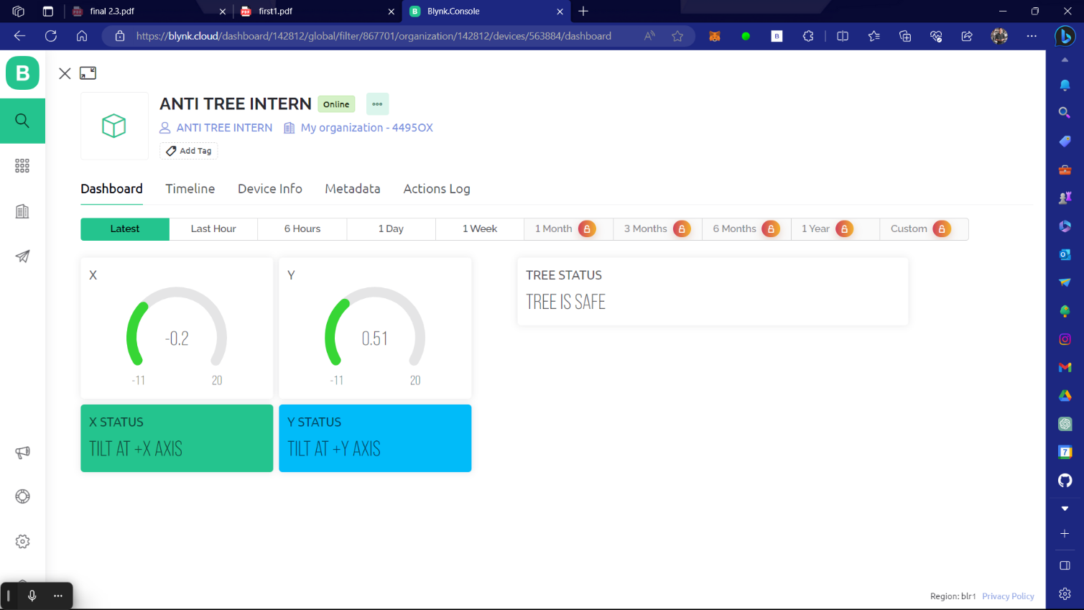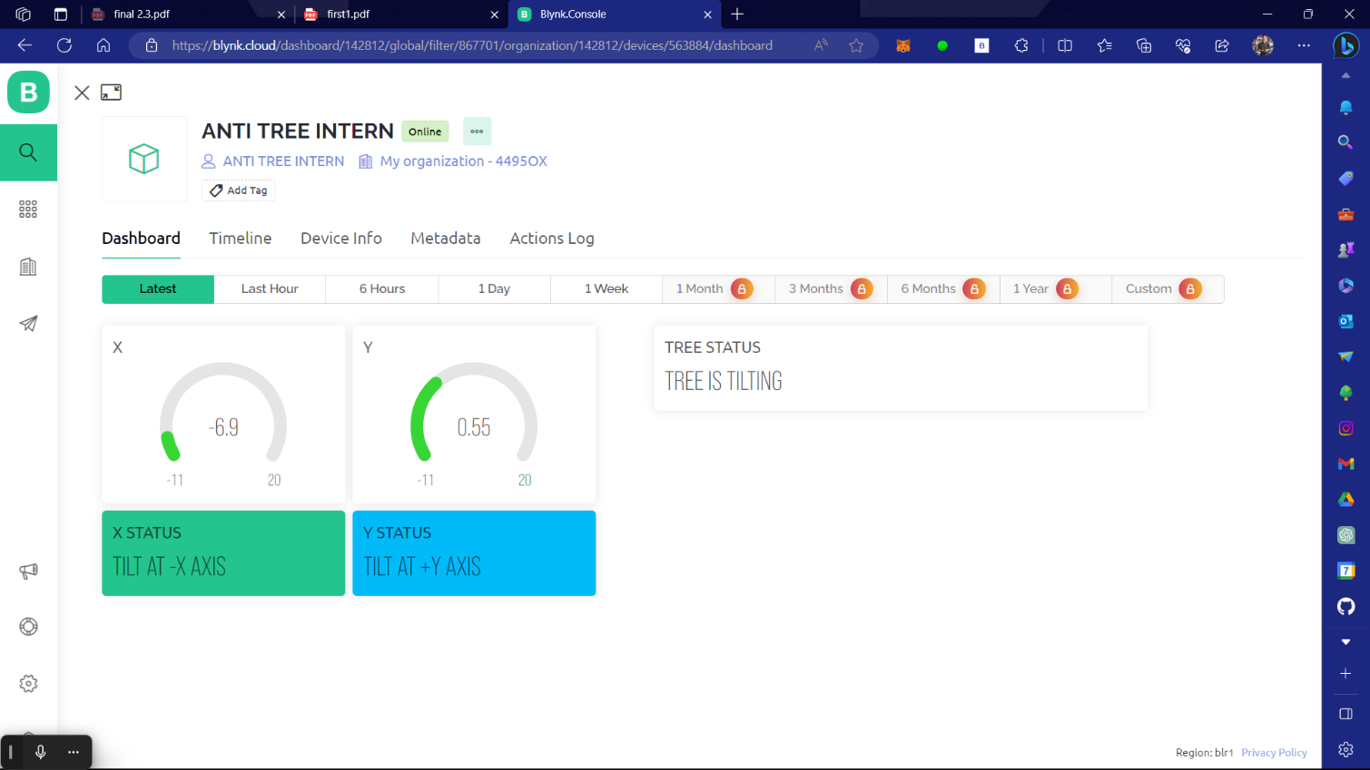

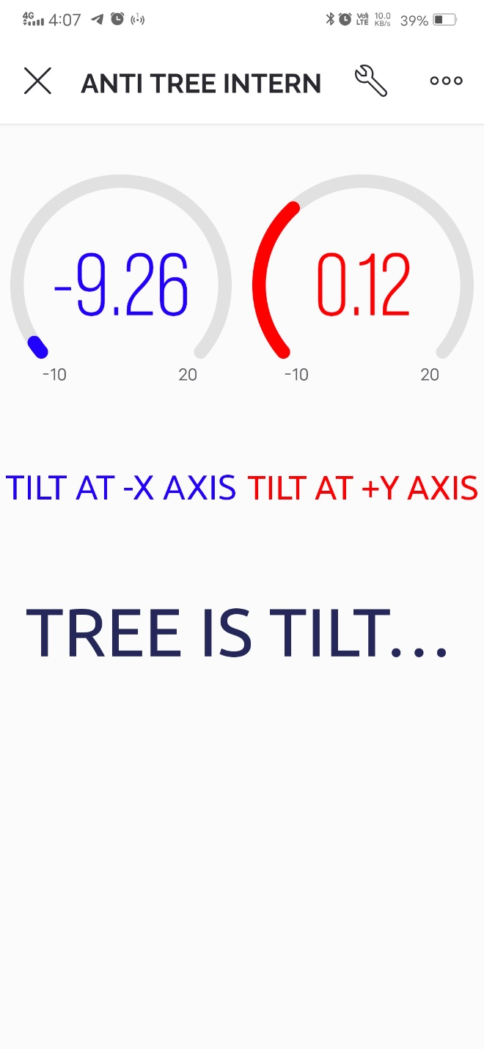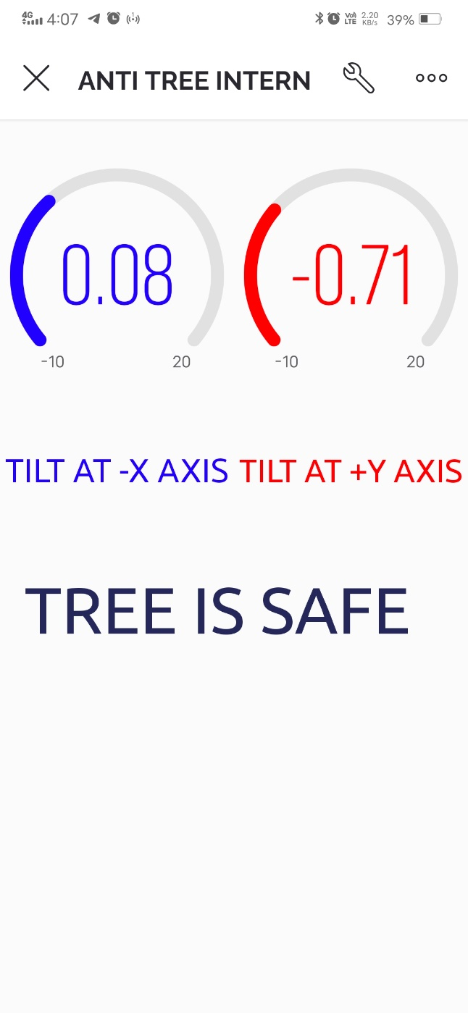

**6.2 CONCLUSION:**

The development of an anti-poaching alarm system for trees can play a crucial role in curbing illegal activities such as tree poaching, logging, and forest fires. By integrating various hardware components such as sensors, microcontrollers, and communication modules, the system can effectively monitor and detect unauthorized activities in forests.

The system provides several technical outcomes, including real-time monitoring of environmental conditions such as temperature, humidity, and gas levels, which can help identify potential threats like forest fires. It also incorporates motion sensors and cameras to detect and capture evidence of illegal activities, enabling timely intervention by authorities.

With the use of wireless communication technologies, the system can transmit data to a centralized base station, allowing forest management personnel to monitor the situation remotely.

Overall, the anti-poaching alarm system acts as a deterrent, raising awareness and minimizing the impact of poaching and illicit logging on the environment and local communities. By protecting valuable tree species like sandalwood, the system contributes to the conservation efforts and sustainable management of forests, ultimately preserving biodiversity and maintaining ecological balance

**REFERENCES**

1. Kapoor, A., & Anand, S. (2018). Smart anti-poaching system using wireless sensor networks. 2018 International Conference on Advances in Computing, Communication Control and Networking (ICACCCN). doi: 10.1109/ICACCCN.2018.8745589
2. Shukla, D., & Kumar, A. (2017). Design and implementation of anti-poaching system using IoT. 2017 International Conference on Big Data Analytics and Computational Intelligence (ICBDAC). doi: 10.1109/ICBDAC.2017.8342203
3. Patel, A. A., Sharma, P. R., & Kanani, D. S. (2019). Smart anti-poaching system based on IoT. 2019 International Conference on Innovative Computing and Communication (ICICC). doi: 10.1109/ICICC.2019.8742952